202B – 120W User Manual

Features

202B – 120W CMOS Black & White Wireless Micro Camera and Receiver set is known for its high quality video and low illumination requirement. It is used at homes, workshops, warehouses, schools, offices, stores, gas stations, and any places that wiring is not possible. It is also used by private investigators and law enforcement agencies for surveillance and video monitoring. Main features include wireless transmission and reception, long reception range, small compact size and minimal weight, low power consumption, high sensitivity, low maintenance, easy installation and operation, and easy concealment.

Package Content
One (1) 202B Wireless Micro Camera, one (1) 120W Wireless Receiver, one (1) DC 9V Power Adapter (for receiver), one (1) DC 8V Adapter (for camera), one (1) 9V Battery Clip, one (1) Video Cable.

Operation Instructions
(see Typical Connecting Model on the back for reference)

- Attach (twist) Reception Antenna to Wireless Receiver.
- Connect Wireless Receiver to Monitor with Video Cable.
- Connect DC 9V Power Adapter to Power Jack of Wireless Receiver.
- Connect DC 8V Power Adapter to Power Supply Socket of Wireless Camera. (Note incorrectly connecting the Wireless Camera to the 9V Power Adapter may cause permanent camera damage.)
- Now everything is connected. Adjust Frequency Controller on Wireless Receiver to a position that best picture quality is achieved.
- Adjust Wireless Camera lens to a position that picture is in focus.
- Mount Wireless Camera to a fixed position if needed.

Specifications

Effective Reception Range | Up to 1000 feet “line of sight”
Resolution | 400 lines
Scan Frequency | EIA: 60 Hz
Output Frequency | 0.9 - 1.2 MHz
Minimum Illumination | 0.5 LUX
TV System | NTSC
Output Power | 200 mW
Power Supply | DC 8V, 9V
Power Consumption | < 960 mW
Camera Dimensions | 20 mm x 20 mm x 13 mm
Receiver Dimensions | 59 mm x 115 m x 20 mm

Usage Agreement

The manufacture or the distributor/reseller of this device(s) cannot be held liable under any circumstances if the device(s) is used for illegal purposes, offenders are subject to severe legal punishments by government law enforcement agencies.
202B – 120W Typical Connecting Model (not to scale)

Reception Antenna
Frequency Controller

DC 9V Adapter  Wireless Receiver  (120W)  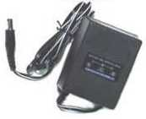  Power Jack | 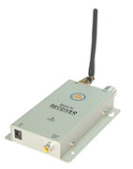 | Monitor (not included)  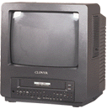
Transmission Antenna | Wireless Camera  (202B)  Video Cable | 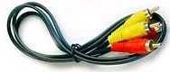
Battery Clip  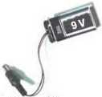  Power Supply Socket | 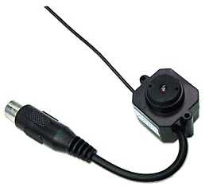
 | or | DC 8V Adapter
Lithium Rechargeable Battery  (not included) | 