208CA-120WA Wireless Camera & Receiver Kit

Features

208CA CMOS Color Wireless Micro Camera and Matching Receiver kit provides high quality wireless video transmission. It is an enhanced model with audio capability. It is used at homes, workshops, warehouses, schools, offices, stores, gas stations, and any places that wiring is not possible. It is also used by private investigators and law enforcement agencies for surveillance and video monitoring. Main features include wireless transmission and reception, long reception range, small compact size and minimal weight, low power consumption, high sensitivity, low maintenance, easy installation and operation, and easy concealment. Beside the standard lens that comes with the 208CA camera, a series of interchangeable lenses for different usages/purposes can be purchased to server your special needs.

Package Content
One (1) 208CA Wireless Micro Camera with standard lens, One (1) 120WA Wireless Receiver, One (1) DC 9V/12V Power Adapter (for receiver), One (1) DC 8V Power Adapter (for camera), One (1) 9V Battery Clip, One (1) Audio/Video Cable.

Operation Instructions
(see Typical Connecting Model on the back for reference)

- Attach (twist) Reception Antenna to Wireless Receiver.
- Connect Wireless Receiver to Monitor or VCR/recording device with Audio/Video Cable.
- Connect DC 9V/12V Power Adapter to Power Jack of Wireless Receiver.
- Connect DC 8V Power Adapter to Power Supply Socket of Wireless Camera. (Note incorrectly connecting the Wireless Camera to the 9V/12V Power Adapter may cause permanent camera damage.)
- Remove (pop off) the lens-protecting cap from the camera lens. Now everything is connected. Adjust Frequency Controller on Wireless Receiver to a position that best picture quality is achieved.
- Adjust Wireless Camera lens to a position that picture is in focus.
- Mount Wireless Camera to a fixed position if needed.

Specifications

Effective Reception Range | Up to 500 feet “line of sight”
Resolution | 380 lines
Scan Frequency | EIA: 60 Hz
Output Frequency | 0.9 - 1.2 MHz
Minimum Illumination | 2 LUX
TV System | NTSC
Output Power | 50 mW
Power Supply | DC 8V, 9V/12V
Power Consumption | < 960 mW
Camera Dimensions | 25 mm x 33 mm x 33 mm
Receiver Dimensions | 59 mm x 115 m x 20 mm

Usage Agreement

The manufacture or the distributor/reseller of this device(s) cannot be held liable under any circumstances if the device(s) is used for illegal purposes, offenders are subject to severe legal punishments by government law enforcement agencies.
208CA – 120WA Typical Connecting Model (not to scale)
Frequency Controller
Reception Antenna
Monitor (not included)
DC 9V/12V Adapter  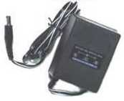  Power Jack | 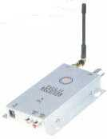  Wireless Receiver  (120WA) | 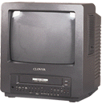
 | Transmission Antenna | Audio Video Cable  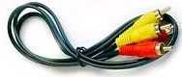
Wireless Camera  (208CA)  Battery Clip  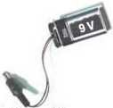  Power Supply Socket | 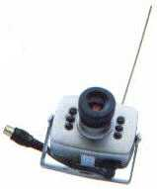
 | or | DC 8V Adapter
Lithium Rechargeable Battery  (not included) | 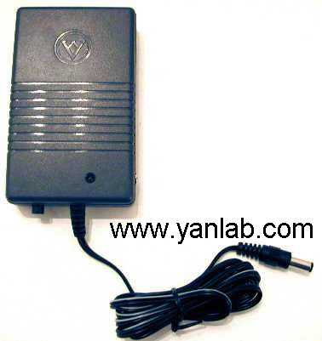 | Interchangeable Lenses  (not included)  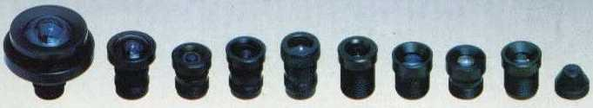  Available at www.RockyAmericas.com

