Lithium Rechargeable Battery User Manual

Features

In order to support mobile operation of wireless surveillance micro cameras, a specially designed lithium rechargeable 8V battery has been developed. The lithium rechargeable batter features small compact size (96mm x 23mm x 58mm), light weight, and long operating service time of up to 15 hours on one charge for wireless surveillance micro cameras, and up to 3 days for wired cameras.

Package Content
- One (1) 8V Lithium Rechargeable Battery
- One (1) Universal 110V – 250V Battery Charger

Operation Instructions
(see Typical Connecting Model on the back for reference)

- Charge the battery before use. Plug the Charger Power Output Cable into the battery Charger Socket. Plug the charger into wall AC outlet. The Charger Indicator Light is on. Charging completes in about 6-8 hours.
- Set up the wireless receiver according to camera/receiver set user manual before connect battery with camera.
- Plug the batter Power Output Cable into the camera Power Supply Socket.
- Press the battery On/Off switch, the battery Power Indicator Light is on. The camera is operating. Press the battery On/Off switch again to turn off the power supply.
- The battery Power Indicator Light goes off when the battery runs out, recharge the battery as described above.

Specifications

Output Power Voltage | DC 8V
Battery Capacity | 1500 mA
Duration of Power Supply | Up to 15 hours (50 mW wireless transmission)
Battery Dimensions | 96 mm x 23 m x 58 mm
Battery Charger Input Voltage | AC 110V – 250V (universal)

Usage Agreement

The Lithium Rechargeable Battery is designed for use with DC 8V wireless/wired micro camera only. It might work with other small DC 8V appliances. Users are at their own risks if the battery is used for purposes other than it is designed for.

Lithium Rechargeable Battery Typical Connecting Model (not to scale)
Charger Indicator Light

Charger Socket
Lithium Rechargeable Battery
Wireless Camera
(not included)
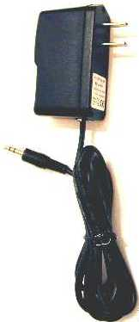  On/Off Switch  Power Indicator Light  Charger Power Output Cable | 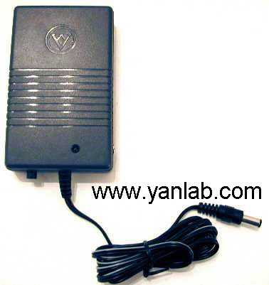  connect | 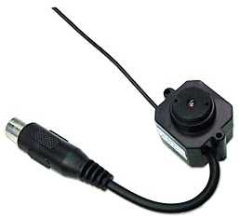  Power Supply Socket
Power Output Cable
Battery Charger

